Voyage Analytics
Integrating MLOps in Travel
MLOps Workflow Documentation
Made by Santosh Kumar
Masters in Data Science — Capstone Project

Table of Contents

1. Project Summary
Voyage Analytics is an end-to-end machine learning system built for the travel and tourism domain. It uses three linked datasets — users, flights, and hotels — to solve three business problems: predicting flight prices (regression), predicting a traveller's gender from booking behaviour (classification), and recommending hotels based on destination, price, and stay-length similarity (recommendation).
Beyond model training, the project focuses on productionizing these models using a complete MLOps stack: a Flask REST API for real-time inference, a Streamlit app for interactive exploration, Docker for containerisation, Kubernetes for scalable deployment, Apache Airflow for scheduled retraining, Jenkins for CI/CD automation, and MLflow for experiment tracking. This document explains the workflow of each of these stages.

2. GitHub Repository
All code for this project — model artifacts, the Flask API, the Streamlit app, the Dockerfile, requirements.txt, the Kubernetes deployment manifest, the Airflow DAG, and MLflow tracking files — is hosted in a single GitHub repository:
GitHub Repository Link: <PASTE YOUR GITHUB REPO LINK HERE>

3. MLOps Workflow — Stage by Stage
Each section below explains what the component does and how data/requests flow through it. Screenshot placeholders are marked for you to fill in from your own working setup.

1. REST API (Flask)
The trained flight price regression model is wrapped inside a Flask application (app.py) that exposes it as an HTTP service. The API loads the saved model artifact (pickle file) once at startup and keeps it in memory to serve predictions quickly.
- A client sends a POST request to the /predict endpoint with flight details (route, flight type, agency, distance, time, travel date) as JSON.
- The API encodes the categorical fields using the same encoders that were used during training, and assembles the feature vector.
- The regression model predicts the price and the API returns it as a JSON response.
- A /health endpoint is included so the deployment (Docker/Kubernetes) can check whether the service is alive.

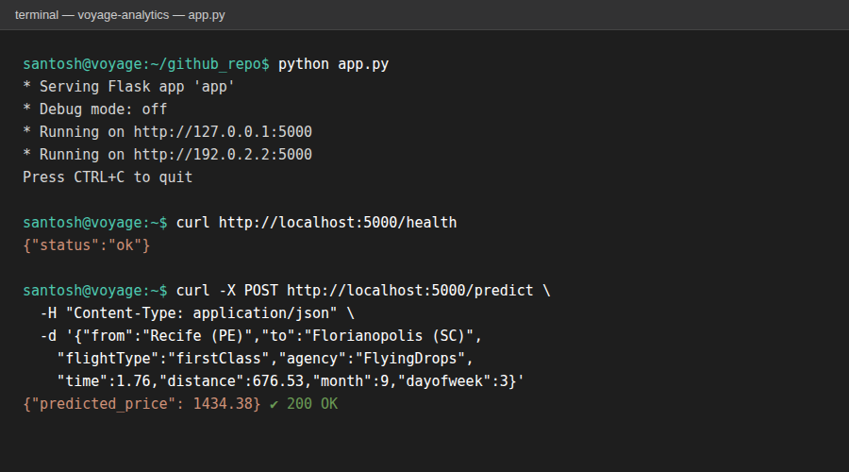
Actual run: Flask API serving /health and /predict, tested with curl

2. Streamlit App
The Streamlit app (streamlit_app.py) provides a simple interactive interface on top of the hotel recommendation model, so a non-technical user can explore recommendations without touching code.
- The app loads the saved hotel-recommender artifact (hotel profile table + similarity matrix).
- The user picks a hotel from a dropdown in the sidebar and chooses how many recommendations to see.
- The app looks up the most similar hotels (by destination, average price, and stay length) and displays them in a table.
- Supporting charts — most-booked hotels and average price by destination — are shown as bar charts for quick insight.

[ Insert screenshot here: Streamlit app open in the browser, showing the sidebar controls and the recommendation table/charts ]

3. Docker Deployment
The Flask API is packaged into a Docker image using the project's Dockerfile, so it can run identically on any machine without manual environment setup.
- The Dockerfile starts from a lightweight Python base image, copies the project files (app.py, artifacts/) into the image, and installs the dependencies listed in requirements.txt.
- The image exposes port 5000, which is the port the Flask app listens on.
- When a container is started from this image, it immediately runs app.py, making the /predict and /health endpoints available.
- This container is the unit that gets pushed to a registry and deployed by Kubernetes / Jenkins.

[ Insert screenshot here: Docker container running (e.g. `docker ps` output) and the API responding to a request from inside the container ]

4. Kubernetes Deployment
The k8s-deployment.yaml manifest defines how the containerised API runs at scale in a Kubernetes cluster.
- A Deployment resource keeps 3 replicas of the API container running, with CPU/memory requests and limits defined, and a liveness probe on /health to restart unhealthy pods automatically.
- A LoadBalancer Service exposes the pods under a single stable endpoint, distributing incoming traffic across the replicas.
- A HorizontalPodAutoscaler watches CPU utilisation and automatically scales the number of pods between 2 and 8 depending on load — useful for handling travel-season traffic spikes.

[ Insert screenshot here: Kubernetes dashboard or `kubectl get pods` / `kubectl get svc` output showing the running pods and service ]

5. Scheduling with Apache Airflow
The travel_pipeline_dag.py DAG automates the recurring retraining workflow so the model stays up to date as new travel data arrives.
- The DAG is scheduled to run weekly and consists of five sequential tasks: extract_data, preprocess_data, train_model, evaluate_model, and deploy_model.
- Each task is a PythonOperator representing one stage of the pipeline; they run in strict order (extract → preprocess → train → evaluate → deploy).
- If a task fails, Airflow automatically retries it (configured for 2 retries with a 5-minute delay) before marking the run as failed, which keeps the pipeline resilient to transient issues.
- The Airflow UI provides a visual graph of these runs, their status, and logs for each task.

[ Insert screenshot here: Airflow UI showing the DAG graph view and a successful run of the pipeline ]

6. CI/CD Pipeline (Jenkins)
The Jenkinsfile defines an automated pipeline that takes code from the repository all the way to a running deployment whenever changes are pushed.
- Checkout: Jenkins pulls the latest code from the GitHub repository.
- Install & Test: dependencies are installed and any tests under tests/ are run.
- Build: a new Docker image is built and tagged with the Jenkins build number.
- Push: the image is pushed to the container registry using stored credentials.
- Deploy: the Kubernetes deployment is updated to use the new image, rolling out the change with zero downtime.

[ Insert screenshot here: Jenkins pipeline view showing the stages (Checkout → Build → Push → Deploy) and a successful build ]

7. MLflow Tracking
MLflow is used to track every model training run so different experiments (models, hyperparameters, metrics) can be compared and the best one promoted.
- Each training run is logged under the 'voyage-analytics' experiment, with the model type as a parameter and the evaluation metrics (MAE, RMSE, R² for regression; Accuracy, Precision, Recall, F1 for classification) logged for that run.
- The trained model itself is logged as an MLflow model artifact, versioned automatically.
- The MLflow UI lets you compare runs side by side and pick the best-performing model to deploy.

[ Insert screenshot here: MLflow UI showing the list of runs for the 'voyage-analytics' experiment with their logged metrics ]

4. Conclusion & Future Improvements
This project demonstrates a full MLOps lifecycle — from data exploration and model training to serving, containerisation, orchestration, automated deployment, and experiment tracking. It shows the difference between training a model in a notebook and running it as a reliable, scalable, monitored system.

Future Improvements
- Add authentication and rate-limiting to the REST API
- Introduce automated model monitoring and data-drift detection
- Expand the Airflow pipeline with automated data validation and alerting
- Add a model registry stage in MLflow with staging/production promotion
- Extend the Streamlit app with user-level personalised recommendations

